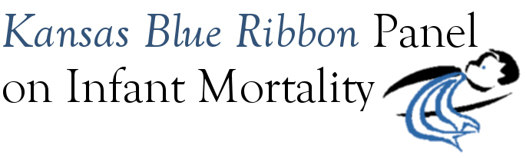

Kansas Blue Ribbon Panel on Infant Mortality
Agenda
1:00 p.m. – 4:00 p.m., Friday, September 24th, 2010
Room 530, Curtis State Office Building, Topeka

1:00 Welcome and Introductions Dennis Cooley, Chair

1:10 Updates
KDHE Jason Eberhart-Phillips
March of Dimes Prematurity Coalition Luncheon Diane Daldrup
Other?

1:25 Proposal: Quality Improvement Collaborative for Perinatal Care Barry Bloom
Discussion

1:55 Three-Month Statewide Awareness Campaign Aiko Allen and Christy Schunn
September: Infant Mortality Awareness Month and Governor’s Proclamation Aiko Allen
October: Sudden Infant Death Syndrome Awareness Month Christy Schunn
November: Prematurity Awareness Month Diane Daldrup
Discussion: How can Blue Ribbon Panel members continue to be involved and support?

2:40 Break

2:55 Preparing for 2011 Legislative Session: Preview of Legislative Issues
KDHE Perspective Jason Eberhart-Phillips
March of Dimes Perspective Diane Daldrup
Other possible legislative opportunities? Blue Ribbon Panel Members
Discussion on potential Blue Ribbon Panel advocacy opportunities during 2011 session

3:45 2011 Dates Panel

3:50 Closing Remarks Dennis Cooley

4:00 Adjourn
Next Meeting: November 19th, 2010 Tentative 2011 Dates: January 21
April 22? (Good Friday) April 29?
July 15
September 16
November 18

