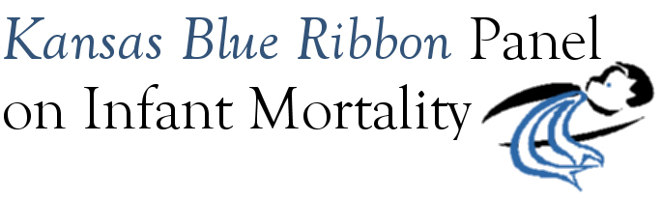

Agenda
1:00 p.m. – 4:00 p.m.
Friday, September 18th, 2009
Curtis State Office Building, Room 530
Topeka

1:00 Welcome and Introductions Dennis Cooley, Chair
Announcements

1:10 KDHE Updates Richard Morrissey

1:20 Presentation: Overview of Panel Progress and Best Practices Linda Kenney

1:55 Presentation: Neonatal Mortality Barry Bloom

2:20 Remarks: Fetal and Neonatal Mortality John Evans

2:35 Break

2:45 Remarks: Advocacy 101 Shannon Cotsoradis

3:00 Panel Discussion Facilitated by Dennis Cooley

Outcome: List of Panel’s Priorities for Short-Term and Long-Term Action

4:00 Adjourn

Next Meeting
Friday, November 20th, 1:00 p.m. – 4:00 p.m. (Joint Meeting with Governor’s Child Health Advisory Committee)

