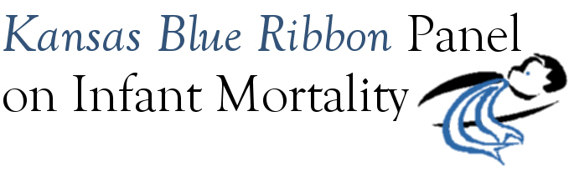

Kansas Blue Ribbon Panel on Infant Mortality
Agenda
1:00 p.m. – 4:00 p.m., Friday, July 30th, 2010
Room 530, Curtis State Office Building, Topeka

1:00 Welcome and Introductions Dennis Cooley, Chair

1:05 KDHE Updates Jason Eberhart-Phillips

1:15 Review of Panel Recommendations Dennis Cooley

1:35 Reports
State Partnership Grant Program to Improve Minority Health Aiko Allen
Affordable Care Act Funding Opportunities Linda Kenney
Funds ($28,000) designated for black infant mortality project Linda Kenney
Overview (Panel input on project selection will be requested during “next steps” discussion)
KATCH Evaluation Project Using PRAMS Questionnaire
KHI: Project Overview Caitlin McMurtry
KDHE Perspective Lou Saadi
Next Steps on FIMR Subcommittee Report

2:35 Break: Celebration of Passage of HB 2454

2:50 Determine Next Steps on Implementing Recommendations Discussion

3:45 Final Thoughts Dennis Cooley

3:55 Next Meeting Date?
Sept. 24th and Nov. 19th have been reserved for CHAC and/or Blue Ribbon Panel meetings.

4:00 Adjourn

