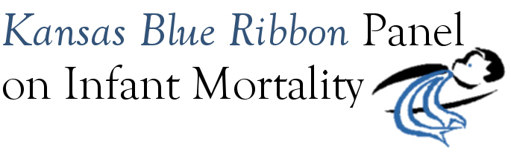

Agenda
1:00 p.m. – 4:00 p.m.
Friday, July 17th, 2009
Curtis State Office Building, Room 530
Topeka

1:00 Welcome and Introductions Dennis Cooley

1:10 Overview of Infant Mortality and the National Fetal and Infant Mortality Review Program
Rosemary Fourier, Michigan State FIMR Program Coordinator
- Presentation
- Question and Answer

2:10 Break

2:20 Overview of Kansas Infant Mortality Gianfranco Pezzino
- Presentation
- Question and Answer

3:15 Panel Discussion

4:00 Adjourn

Upcoming Meeting Dates

August 28th, 1:00 p.m. – 4:00 p.m.
September 18th, 1:00 p.m. – 4:00 p.m. (Joint Meeting with Governor’s Child Health Advisory Committee)

