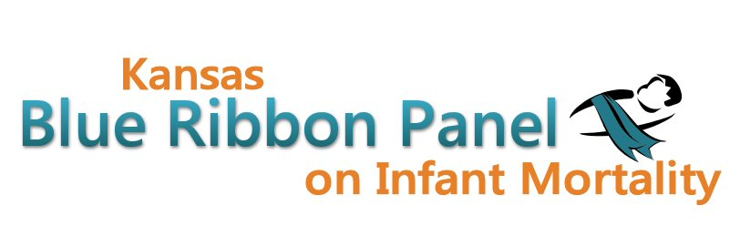

Kansas Blue Ribbon Panel on Infant Mortality
Agenda
1:00 p.m. – 4:00 p.m., Friday, April 29th, 2011
Crumbine Room, Curtis State Office Building, Topeka

Welcome and Introductions Dennis Cooley, Chair

Legislative and Budget Update Shannon Cotsoradis

Overview of PRAMS Startup Schedule Linda Kenney

Infant Mortality Awareness Campaign Aiko Allen
Report on Tonya Lewis Lee Tour
Next Steps

Logic Model Discussion
Review Final Logic Model
Review Intended Uses
Implementation Plan

Additional Updates

Next Steps for the Blue Ribbon Panel

Wrap-up and Adjourn Dennis Cooley

Upcoming Meeting Dates
July 15th
September 16th
November 18th

Websites
Public: http://www.kansasinfantmortality.org/
Member: http://www.datacounts.net/infant_mortality/

