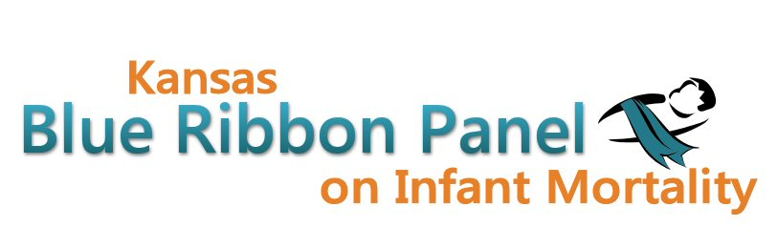

Kansas Blue Ribbon Panel on Infant Mortality
Agenda
April 5th, 2013
1:00 p.m. – 4:00 p.m.
Curtis State Office Building, Crumbine Room
Topeka, Kansas

Welcome and Introductions Dennis Cooley, Chair

KDHE and Legislative Updates KDHE Staff
Legislative and Policy Updates Shannon Cotsoradis, Kansas Action for Children

Kansas Perinatal Quality Collaborative Shalae Harris, Health Initiatives

March of Dimes, ASTHO Challenge Updates Diane Daldrup, Greater Kansas Chapter

Healthy Babies Kansas Statewide Campaign Christy Schunn, KIDS Network, Inc.

Break

Health Options that Matter of Kansas City, Inc. Sharon Lee, President and CEO

Implementation of Bylaws Discussion

Member and Staff Updates
Quality Improvement/Vital Statistics Data Updates Carol Moyer
Other Updates

Other Business

Adjourn

Websites
Public: http://www.kansasinfantmortality.org/
Member: http://www.datacounts.net/infant_mortality/

