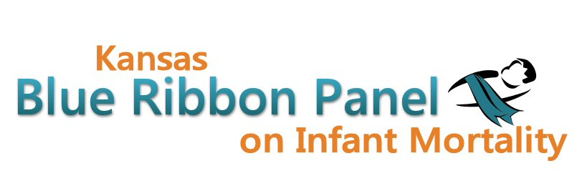

Kansas Blue Ribbon Panel on Infant Mortality
Agenda
Friday, January 25th, 2013
1:00 p.m. – 4:00 p.m.
Curtis State Office Building, Crumbine Room
Topeka, Kansas

Welcome and Introductions Dennis Cooley, Chair

KDHE Updates Dave Thomason, KDHE Bureau of Family Health

Community FIMR Projects Shannon Cotsoradis, Kansas Action for Children

KDHE Outreach Efforts for Pregnant Women and Infants
Wanda Esping, KDHE Division of Health Care Finance

Break

Awareness Campaign Updates Aiko Allen, Center for Health Equity

Kansas Perinatal Quality Collaborative Shalae Harris, Health Initiatives

March of Dimes Update Diane Daldrup, March of Dimes

Child Death Review Board Annual Report Angela Nordhus, Child Death Review Board

Blue Ribbon Panel Bylaws and Member Expectations Dennis Cooley, Dave Thomason

Other Business

Adjourn

Websites
Public: http://www.kansasinfantmortality.org/
Member: http://www.datacounts.net/infant_mortality/

