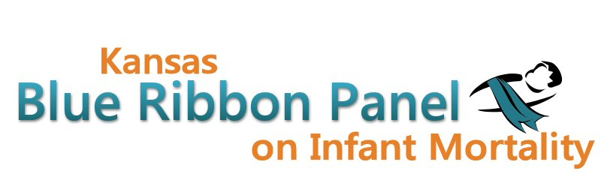

Kansas Blue Ribbon Panel on Infant Mortality
Agenda
Friday, September 21st 2012
1:00 p.m. – 4:00 p.m.
Curtis State Office Building, Crumbine Room
Topeka, Kansas

Welcome and Introductions Dennis Cooley, Chair

Reports
- FIMR Project Kansas Action for Children (Written Report)
- Center for Public Health Sharing Services Catherine Shoults
- Strong Start Grant Update Dave Thomason

Managed Care Organizations Presentations on Prenatal Programs
- Sunflower State Health Plan Jennifer Clark
- United Healthcare of Midwest, Inc. William Downham (phone)
- Amerigroup Kansas, Inc. Karen Shea (phone)
- Discussion

Break

Kansas Perinatal Quality Collaborative Shalae Harris

KDHE/MOD ASHTO Partnership Aiko Allen (on behalf of March of Dimes)

Facebook Campaign Results Aiko Allen

Preconception Peer Educator Training Aiko Allen

Healthy Kansans 2020 – MCH Focus Area Preview Connie Satzler, Dennis Cooley

Other Member Updates

Other Business

Closing Remarks Dennis Cooley

Adjourn

Next Meeting Date
Friday, November 9th, 1:00 – 4:00
Websites
Public: http://www.kansasinfantmortality.org/
Member: http://www.datacounts.net/infant_mortality/

