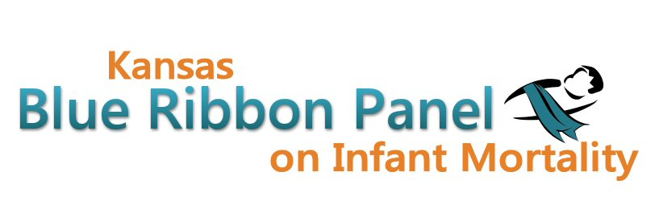

Kansas Blue Ribbon Panel on Infant Mortality
Agenda
Friday, June 29th, 2012
1:30 p.m. – 4:00 p.m.

Welcome and Introductions Dennis Cooley, Chair

Newborn Screening Legislation and Funding Nathan Bainbridge

Infant Mortality Awareness Campaign Aiko Allen

Strong Start Grant Update Dave Thomason

FIMR Conference Report Dave Thomason and Conference Attendees

Investments in Infant Mortality Update Shannon Cotsoradis

Perinatal Collaborative and March of Dimes Grants Diane Daldrup

Mother & Child Health Coalition Updates Jean Craig

Other Member Updates

Other Business

Closing Remarks Dennis Cooley

Adjourn

Next Meeting Date
Friday, September 21st, 1:00 – 4:00
Websites
Public: http://www.kansasinfantmortality.org/
Member: http://www.datacounts.net/infant_mortality/

