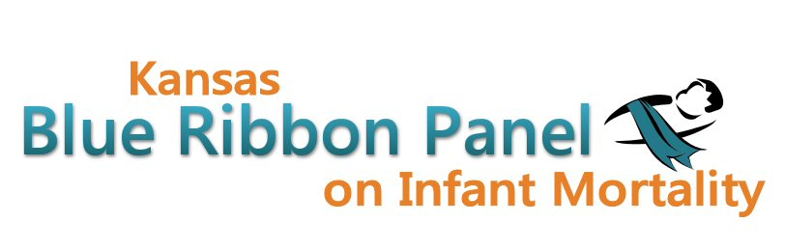

Kansas Blue Ribbon Panel on Infant Mortality
Conference Call Agenda
Thursday, May 3rd, 2012
10:30 a.m. - Noon
Conference call option:
Conference code:
Webinar link: https://www2.gotomeeting.com/join/762186282

Welcome and Introductions Dennis Cooley, Chair

Academy for Team Leadership Shannon Cotsoradis

New Investments in Infant Mortality Shannon Cotsoradis

Newborn Screening Update Nathan Bainbridge

Awareness Campaign Aiko Allen

Strong Start Grant Dave Thomason

Blue Ribbon Panel on Infant Mortality Updates Dave Thomason
Drafting Bylaws for Panel Review
Next Meetings

Other Business

Closing Remarks Dennis Cooley

Adjourn

Next Meeting Dates
Friday, June 29th, 1:30 – 4:00
Friday, September 21st, 1:30 – 4:00
Websites
Public: http://www.kansasinfantmortality.org/
Member: http://www.datacounts.net/infant_mortality/

