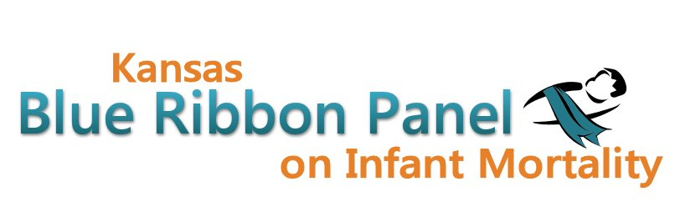

Kansas Blue Ribbon Panel on Infant Mortality
Agenda
Friday, November 16th 2012
1:00 p.m. – 4:00 p.m.
Curtis State Office Building, Crumbine Room
Topeka, Kansas

Welcome and Introductions Dennis Cooley, Chair

Overview of High 5 Campaign Martha Hagen

Perinatal Conference Report Diane Daldrup

Perinatal Collaborative Update Shalae Harris

Statewide Awareness Campaign Aiko Allen

Data Presentations
2011 Vital Statistics Annual Summary Greg Crawford
2011 Selected Special Statistics on Infant Mortality Carol Moyer

Break

Blue Ribbon Panel Bylaws Discussion

Other Member Updates

Other Business

Closing Remarks Dennis Cooley

Adjourn

Websites
Public: http://www.kansasinfantmortality.org/
Member: http://www.datacounts.net/infant_mortality/

