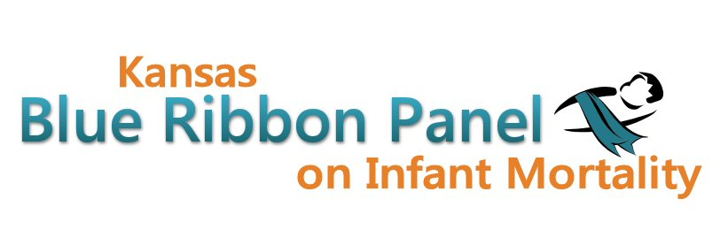

Kansas Blue Ribbon Panel on Infant Mortality
Agenda
January 27th, 2012
1:00 p.m. – 4:00 p.m.
Crumbine Room, Curtis State Office Building, Topeka
Conference call option: (XXX) XXX-XXXX
Conference code: XXX-XXX-XXX

Welcome and Introductions Dennis Cooley, Chair

KDHE and Legislative Updates Secretary Moser

Role of the Blue Ribbon Panel Discussion

NIH Safe Sleep Study Proposal Steve Fawcett

Break

Infant Mortality Awareness Campaign Update Aiko Allen

Preconception Peer Educator Training Aiko Allen

Prematurity Symposium and Quality Collaborative Diane Daldrup

Other Business

Closing Remarks Dennis Cooley

Adjourn

Websites
Public: http://www.kansasinfantmortality.org/
Member: http://www.datacounts.net/infant_mortality/

