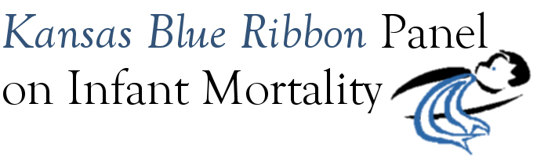

Kansas Blue Ribbon Panel on Infant Mortality
Draft Agenda
1:00 p.m. – 4:00 p.m., Friday, January 21st, 2011
Room 530, Curtis State Office Building, Topeka

1:00 Welcome and Introductions Dennis Cooley, Chair

1:05 PRAMS Update Linda Kenney

1:10 Infant Mortality Awareness Aiko Allen
Fall 2010 Campaign
Spring 2011 Planned Activities
Panel Feedback and Recommendations

1:30 Perinatal Collaborative Update

1:35 Continuation of Logic Model Work Steve Fawcett
Review, refine, and adopt logic models
Discussion: How logic models can be used to further Panel’s mission
Discussion: Priorities and Next Steps Dennis Cooley

3:55 Wrap-up

4:00 Adjourn

2011 Meeting Dates
January 21st
April 29th
July 15th
September 16th
November 18th

