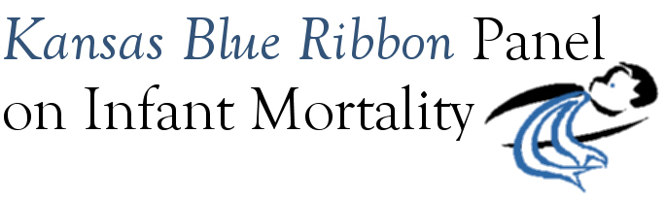

Kansas Blue Ribbon Panel on Infant Mortality
Agenda
1:00 p.m. – 4:00 p.m., Friday, February 18th, 2011
Crumbine Room, Curtis State Office Building, Topeka

1:00 Welcome and Introductions Dennis Cooley, Chair

1:05 Logic Model Work: Report and Discussion Steve Fawcett
Overall Logic Model (adopted by Panel at January meeting)
State Systems Logic Model Linda Kenney
Safe Sleep Logic Model Christy Schunn and Angela Nordhus
Access and Social Supports Logic Model Dennis Cooley
Possible Panel action: Adopt remaining logic models

2:20 Break

2:30 Discussion on Intended Uses and Implementation of Logic Model Steve Fawcett

3:10 Tonya Lewis Lee Three-City Tour Promoting Healthy Babies: April 20th – 22nd
Overview Aiko Allen
Preview of Wichita Events Shalae Harris and Christy Schunn
Preview of Topeka Events Mildred Edwards
Preview of Kansas City Events Susan McLoughlin
How Panel Members Can Be Involved Aiko Allen

3:45 Wrap-up and Next Steps Dennis Cooley

4:00 Adjourn

Upcoming Meeting Dates
April 29th
July 15th
September 16th
November 18th

