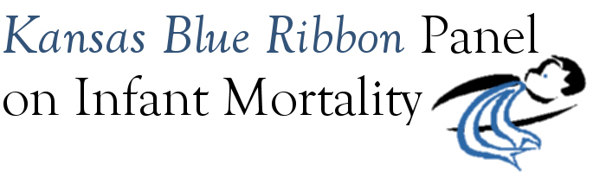

Governor’s Child Health Advisory Committee
Joint Meeting with Blue Ribbon Panel on Infant Mortality

DRAFT Agenda
1:00 p.m. – 4:00 p.m.
Friday, November 20th, 2009
Room 530, Curtis State Office Building, Topeka

1:00 Welcome and Introductions Dennis Cooley, Chair
Announcements

1:10 USDA/WIC Food Package Recommendation Letter Regarding Formulas and Quantities Appropriate for Premature Infants Patricia Dunavan
- Presentation
- Question and Answer
- Possible Action by CHAC: Approve Recommendation Letter

1:30 Blue Ribbon Panel Recommendations to CHAC Dennis Cooley
- Review Recommendations
- Facilitated Discussion
- Possible Actions by CHAC: Modify, Approve Panel Recommendations

2:35 Break

2:45 Review of Best and Promising Practices to Address Infant Mortality Janine Lewis
- Presentation
- Question and Answer
- Facilitated Discussion
- Possible Action by Blue Ribbon Panel or CHAC: Identify Next Steps/Follow-up on New Information Presented

4:00 Adjourn

