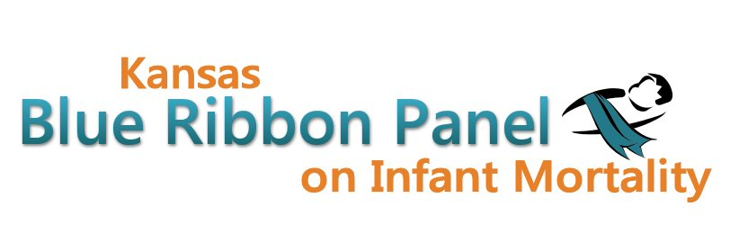

Kansas Blue Ribbon Panel on Infant Mortality
Agenda
1:00 p.m. – 4:00 p.m.
November 18th, 2011
Room 530, Curtis State Office Building, Topeka

Welcome and Introductions Dennis Cooley, Chair

KDHE, Medicaid and Title V Updates David Thomason

Fall 2011 Infant Mortality Three-Month Awareness Campaign Report Christy Schunn

Prematurity Conference Report Diane Daldrup

Break

Study of Infant Mortality among Military Beneficiaries Paul Benne

Perinatal Periods of Risk (PPOR) Phase 1 and 2: A State Level Analysis in Kansas, 2005-2009
Jamie Kim

Pertussis Cocooning Elizabeth Lawlor

Other Business

Closing Remarks Dennis Cooley

Adjourn

Websites
Public: http://www.kansasinfantmortality.org/
Member: http://www.datacounts.net/infant_mortality/

