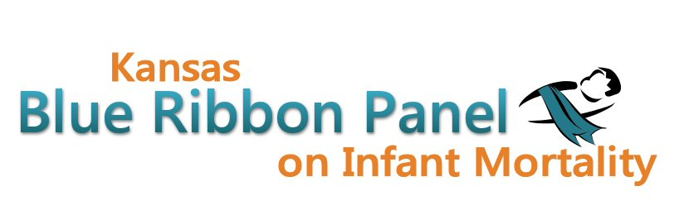

Kansas Blue Ribbon Panel on Infant Mortality
Agenda
1:00 p.m. – 4:00 p.m.
September 30th, 2011
Crumbine Room, Curtis State Office Building, Topeka

Welcome and Introductions Dennis Cooley, Chair

Blue Ribbon Panel Updates
KPHA Poster Presentation: Perinatal Periods of Risk State Level Analysis Jamie Kim
PRAMS Next Steps
Other?

Fall 2011 Infant Mortality Awareness Campaign Aiko Allen and Christy Schunn
Governor’s Proclamations
Other Awareness Activities and Available Resources
Panel Member Involvement
Brush Art Contract

Final Review of Simplified Logic Model

Break

Revisit February 2010 Interim Recommendations

Current and Future Purpose and Outcomes of the Blue Ribbon Panel
KDHE Perspective David Thomason
Discussion

Other Business

Meeting Schedule for 2012?

Closing Remarks Dennis Cooley

Adjourn

Next Meeting
November 18th

Websites
Public: http://www.kansasinfantmortality.org/
Member: http://www.datacounts.net/infant_mortality/

